Some questions:
- When David sinned through adultery and murder, God took away his son. Isn’t that an example of God visiting the sin of the father on the child?
- Using the example above, David repented but nevertheless his son died; yet you said through Ezekiel 18 that God is merciful and ready to grant live to those who repent. Should God have spared the life of the baby?

Theological question 8:
Zedekiah has a decent plan; surely he can bring us out of our trouble!

god’s answer

19 “Moreover take up a lamentation for the princes of Israel, ² and say:
‘What is your mother? A lioness:
She lay down among the lions;
Among the young lions she nourished her cubs.
³ She brought up one of her cubs,
And he became a young lion;
He learned to catch prey,
And he devoured men.
⁴ The nations also heard of him;
He was trapped in their pit,
And they brought him with chains to the land of Egypt.
⁵ ‘When she saw that she waited, that her hope was lost,
She took another of her cubs and made him a young lion.
⁶ He roved among the lions,
And became a young lion;
He learned to catch prey;
He devoured men.
⁷ He knew their desolate places,
And laid waste their cities;
The land with its fullness was desolated
By the noise of his roaring.
⁸ Then the nations set against him from the provinces on every side,
And spread their net over him;
He was trapped in their pit.
⁹ They put him in a cage with chains,
And brought him to the king of Babylon;
They brought him in nets,
That his voice should no longer be heard on the mountains of Israel.
¹⁰ ‘Your mother was like a vine in your bloodline,
Planted by the waters,
Fruitful and full of branches
Because of many waters.
¹¹ She had strong branches for scepters of rulers.
She towered in stature above the thick branches,
And was seen in her height amid the dense foliage.
¹² But she was plucked up in fury,
She was cast down to the ground,
And the east wind dried her fruit.
Her strong branches were broken and withered;
The fire consumed them.
¹³ And now she is planted in the wilderness,
In a dry and thirsty land.
¹⁴ Fire has come out from a rod of her branches
And devoured her fruit,
So that she has no strong branch— a scepter for ruling.’ ”
This is a lamentation, and has become a lamentation.

Lioness, young lions:- Royal family, descendants of David. （see Genesis 49:8-9）

To understand this parable we need to look at Judah’s history.
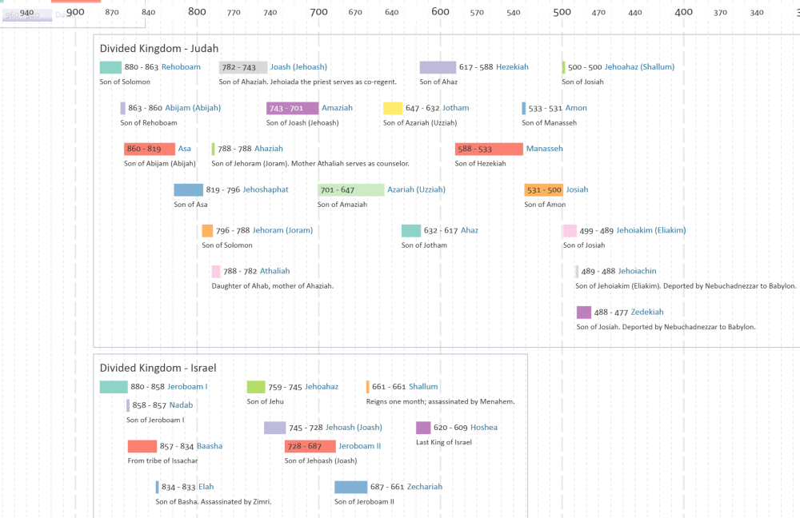

First Lion
Who are we talking about?
³¹ Jehoahaz was twenty-three years old when he became king, and he reigned three months in Jerusalem. His mother’s name was Hamutal the daughter of Jeremiah of Libnah. ³² And he did evil in the sight of the Lord, according to all that his fathers had done. (2 Kings 23:31-32)
Learned to catch pray: familiar with all matters of statecraft and war.
Devoured men: A reference to the evil deeds of King Jehoahaz.
Nations heard of him: He made his presence felt in the political affairs around Israel.
What happened to him? (See 2 Kings 23:33-34)
³³ Now Pharaoh Necho put him in prison at Riblah in the land of Hamath, that he might not reign in Jerusalem; and he imposed on the land a tribute of one hundred talents of silver and a talent of gold. ³⁴ Then Pharaoh Necho made Eliakim the son of Josiah king in place of his father Josiah, and changed his name to Jehoiakim. And Pharaoh took Jehoahaz and went to Egypt, and he died there.

Second Lion
Who are we talking about? (2 Kings 23:35-37)
³⁵ So Jehoiakim gave the silver and gold to Pharaoh; but he taxed the land to give money according to the command of Pharaoh; he exacted the silver and gold from the people of the land, from every one according to his assessment, to give it to Pharaoh Necho. ³⁶ Jehoiakim was twenty-five years old when he became king, and he reigned eleven years in Jerusalem. His mother’s name was Zebudah the daughter of Pedaiah of Rumah. ³⁷ And he did evil in the sight of the Lord, according to all that his fathers had done.
Some facts about Jehoiakim:
He became king at age of 25.
He ruled Judah for 11 years.
Verse 7 can be referenced to Jeremiah 22:1-7 as a indicator of his evil deeds
What happened to him? (See 2 Kings 24:2; and more in 2 Chronicles 36:6)
⁶ Nebuchadnezzar king of Babylon came up against him, and bound him in bronze fetters to carry him off to Babylon. ⁷ Nebuchadnezzar also carried off some of the articles from the house of the Lord to Babylon, and put them in his temple at Babylon. ⁸ Now the rest of the acts of Jehoiakim, the abominations which he did, and what was found against him, indeed they are written in the book of the kings of Israel and Judah. Then Jehoiachin his son reigned in his place.

Vine and branches
Who is being mentioned here? Zedekiah
Why the change in images (from lions to vine)?
Vine: Represents Judah (v11 talks about how Judah has been a fertile ground for many rulers)

Verses 12-14 are a prophecy on the end of Zedekiah’s rule and the fate of Jerusalem (Judah).

Conclusion
Zedekiah is not worthy to put your trust in!

Lessons for us

